Dr. Ahene’s Bio and Picture 2023

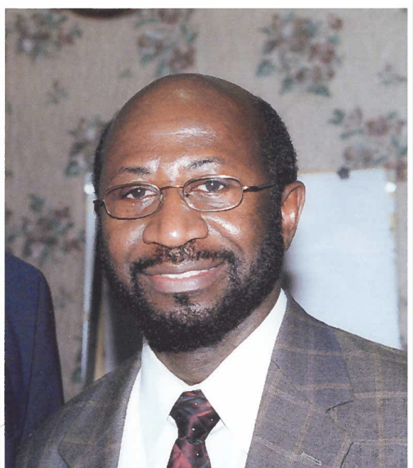

Dr. Rexford A. Ahene is an emeritus economics and policy studies professor with more than 30 years of experience as a consultant and technical advisor for the World Bank, FAO, AfDB, and the United Nations Development Program. Dr. Ahene's research focuses on land policy and land administration reforms and analysis of land markets in Africa. He was the principal author of the Land Policy of Tanzania in 1995 and the Malawi National Land Policy of 2000; supervised the design and development of the Uganda Land Information System 2008-2013 and was the principal editor of the VGGT-compliant Sierra Leone National Land Policy, 2015. Dr. Ahene has served as the Chair of the Scientific Committee, responsible for organizing the AU-UNECA-sponsored Conference on Land Policy in Africa since its inception in 2014, and Editor for the African Journal on Land Policy and Geospatial Sciences, a journal specialized in publishing research activities carried out in the field of geospatial sciences and land governance. He has published books and numerous articles in professional journals and serves on several editorial boards. He is a member of the Urban Land Institute, American Economic Association, African Studies Association, National Tax Association, and an affiliate member of the Lincoln Institute for Land Policy Studies. Dr. Ahene received his Masters and Ph.D. from the University of Wisconsin, Madison, and continues to provide technical advice for designing and implementing land policy, land governance, and land administration reform programs.